Beatz

Drums

How to make them knock

Saturation / Pre Amp
For adding more harmonics to your drums.

Plugins:
- Flstudio: Distructer, Fruity Blood Overdrive
* Ableton: Drum Bus, Saturator, Dynamic Tube
- Vsts: Saturation Knop

Boosting 60-75 hz
For making tha bass fatter.

Plugins:
- Flstudio: Fruity parametric EQ 2
- Ableton: EQ Eight
- Vsts: TDR Nova

Limiter / Soft Clipper
For making the drums more edgier and compressed.

Plugins:
- Flstudio: Fruity Soft Clipper
- Ableton: Glue Compressor
- Vsts: Initial Clipper

Pattern

Trap
BPM : 120-160
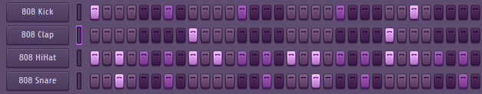

Kick and 808:
The Kick and 808 usually play on at the same Time. Most of the time they follow this pattern or parts of this pattern. But there also one other pattern that is often used for kick and 808:
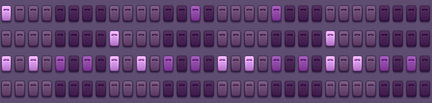

Clap
The Clap always plays this pattern.

Snare
The Snare can be played where ever you want, but it sounds better in the off beats.

Hats
The HiHats plays most of the time every 2 steps. You can also add some hihat rolls.

Open Hats
Open Hihats can be placed where ever you want, but hey sound got on the onBeats.

R&B
BPM : 50-120 (most popular songs are around 100 bpm)
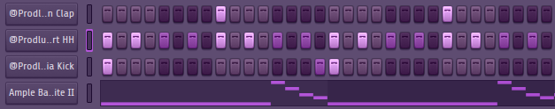

Kick:
The Kick plays most of the time just on the 1 and the 3.

Clap
The clap always plays on the 2 and 4.

Hats
Hihat plays every 2 steps.

Tipps
You can make the grid 6/8 for more unique sound. You can pitch your beat down, to sound slower.

Boom Bap
BPM : 80-90
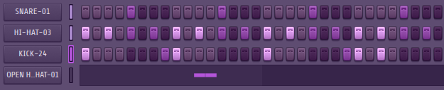

Kick:
The Kick is the fundemental in the Beat. This is the most popular pattern but there are other patterns that also works.

Snare
The Snare always plays on the 2 and 4.

Hats
Hihat plays every 2 steps.

Tipps
You can play your beat live as midi, for more naturelle sound. Try to use drum sounds that fit together.

Pop Rock
BPM : 100-110
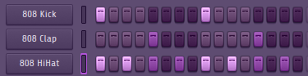

Kick:
The Kick always plays on the 1 and 3.

Snare
The Snare always plays on the 2 and 4.

Hats
Hihat plays every 2 steps.

Tipps
Pop Rock is mostly this simple beat, to attention to the singer.

Tipps
You can add shifft to your drum sounds to make the beat more realistic and interisting.

Melody

Easy Musik Theorie
You can move your root note major chord 3 semitones down to make it a minor chord, or you make the chord just minor with the same rootnote.

Melody made Easy
- Rythem
Make a rythem or an arpegio.
- Low Layer
Make a low layer with a dark instrument and try to make a call and respons with the rythem.
- Harmonie Layer
Make the chords string or piano.
- Topline
repetetif pattern. Up an octave.

